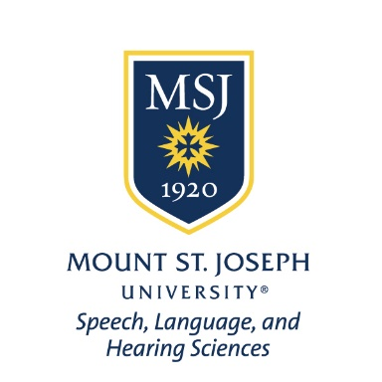
Speech, Language, and Hearing Sciences
Consent to Treat & Financial Agreement Form

PATIENT FULL NAME _________________________________________________

DATE OF BIRTH _______________________

Thank you for choosing the Department of Speech, Language, and Hearing Sciences at MSJ to provide services for you and your family. By signing this form, you are indicating that:

1) You give consent for the Department of Speech, Language, and Hearing Sciences at MSJ to treat you and/or your family member.

Consent for Screening/Evaluation: YES_____ NO______

Consent for Individual Sessions: YES______ NO______

Consent for Group Sessions: YES______ NO______

*Consent for Telehealth Sessions: YES_____ NO_____

2) You understand the financial policy of the Department of Speech, Language, and Hearing Sciences.

Financial Policy:
Currently, the Department of Speech, Language, and Hearing Sciences does not charge a fee for individual services or group sessions. All individual and group sessions are provided for free.

Please sign below to acknowledge you have reviewed and understand these policies.

Signature:___________________________________________Date:_____________

Relationship to patient:____________________

*A secure platform (Zoom) with privacy protection is used for telehealth sessions

