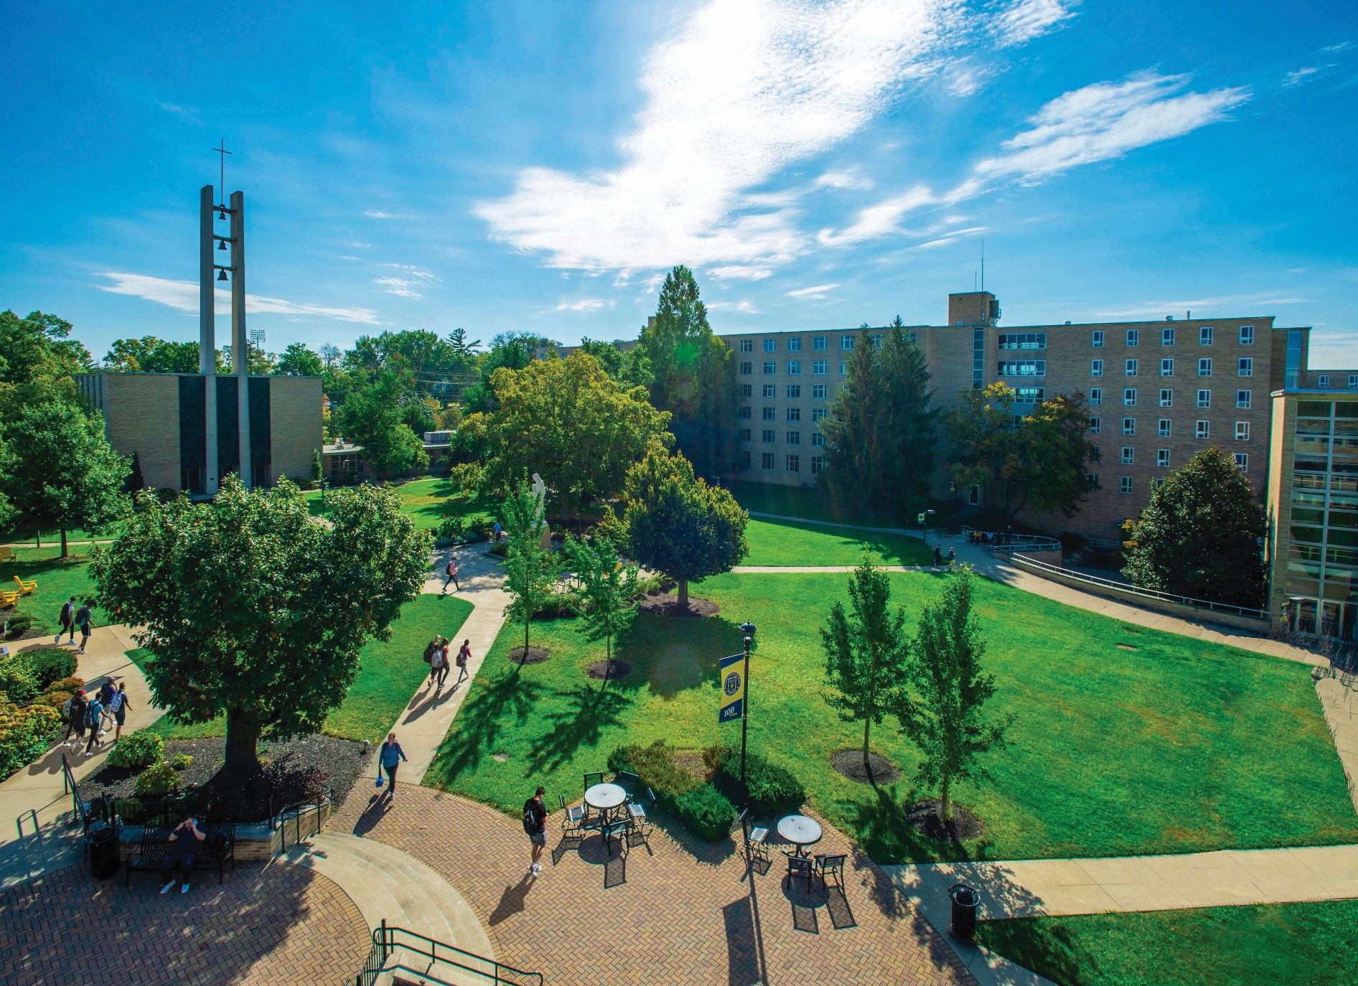
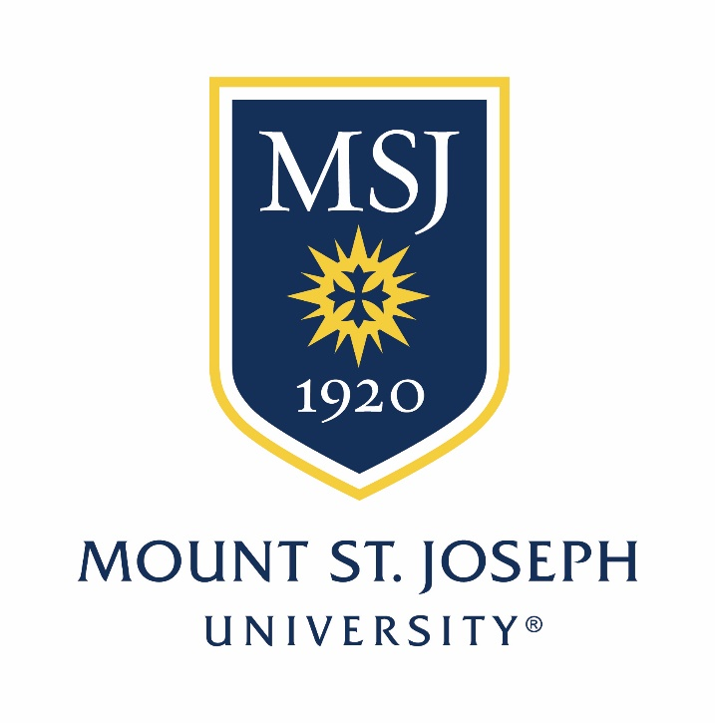

Invites Applications and Nominations for the Position of:

Provost

The Opportunity
GREENWOODSEARCH.COM

The Provost serves as the University’s chief academic officer. Reporting to the President, the Provost serves as the leader and administrator of the University’s division of academic affairs and oversees academic support services, campus technology, and institutional research. The Provost plays a central role in fulfilling the University’s mission and vision and accomplishing the goals of the University’s strategic plan, Transformation 2025, including supporting student recruitment and retention. The Provost is also responsible for ensuring academic quality and maintaining regional accreditation. The Provost serves as a member of President’s Cabinet and advises the President on issues related to faculty, academic programs, student support services, and technology.

The University budget is $52M and the Provost oversees an annual budget of $20,082 million. Mount St. Joseph University educates 2,027 students and employs 493 faculty and staff, and is composed of five schools: Arts & Humanities, Behavioral & Natural Sciences, Business, Education, and Health Sciences. The University offers 40 programs from which to choose https://www.msj.edu/academics/.

As a member of the President’s Cabinet, the Provost will collaborate with the President and other administrative officers to achieve University goals. This position has overall responsibility for the Division of Academic Affairs which includes all academic schools, Academic Support Services, Information Services and Support, and Institutional Research, with direct supervision of three Associate Provosts, five Academic Deans, and the Director of Institutional Research. The Provost also coordinates Academic Leadership Council and the Faculty Salary Workload Advisory Committee.

The Role of the Provost

The Provost is the chief academic administrator of the University, responsible for academic programs, academic policy, curriculum, divisional budgets, and strategic planning; representing the University to external bodies; and academic planning. The Provost provides leadership, direction, coordination, and supervision for the following positions, groups, and offices:
- Associate Provost for Academic Affairs;
- Associate Provost for Academic Support;
- Associate Provost for Campus Technology;
- the academic schools and their respective Deans;
- the Office of Institutional Research; and
- the Academic Leadership Council and Faculty Salary Workload Advisory Committee.

The Provost also serves the following important roles:

- ensures the integrity, security, and quality of campus technology services;
- ensures the integrity and quality of data governance, reporting, and support services;
- oversees development and implementation of academic strategic planning;
- promotes collaboration and innovation within the academic affairs division and across campus;
- works in close cooperation with Faculty Assembly and other faculty governance bodies;
- supervises budgeting and allocation of resources among all units reporting to the Provost;
- oversees faculty and academic staff recruitment, compensation, development, and retention;
- provides advisory recommendations to the President on all academic appointments and tenure and promotion matters;
- ensures educational quality, through a variety of mechanisms, including robust program and core curriculum assessments and regular academic program review;
- supports institutional enrollment goals, through new program development, ensuring quality and distinctiveness of existing programs, and program-level recruiting;
- supports institutional student retention efforts by ensuring the quality of academic advising, academic support services, and program-level retention strategies;
- collaborates on academic and academic-support-related grant acquisition and implementation;
- Acts as the HLC ALO, and manages all accreditation requirements and communications with HLC (Higher Learning Commission) and ODHE (Ohio Department of Higher Education);
- communicates effectively with students, employees, and other stakeholders;
- as key counsel to the President, serves as a liaison in resolving academic concerns and issues;
- serves as primary University staff liaison to the Student Experience Committee of the Board of Trustees;
- serve as chief administrative officer in the absence of the President, as requested;
- provides overall day-to-day leadership with integrity, commitment, and concern for staff, faculty, administrators, and, above all, for the individual student and the student’s academic progress and success; and
- performs other duties as requested by the President.

Qualifications

The Provost must possess the following qualifications.
- An earned doctorate and a record of teaching excellence, service, and scholarship that qualifies for an appointment to the rank of a tenured professor.
- Minimum of 10 years of experience in higher education, with at least five years in an academic administrative role.
- Good verbal and communication skills and an ability to build relationships of trust and integrity at all levels of the institution.
- Personnel and budget management, strategic planning, and program development experience.
- Accreditation experience.

Skills and Attributes
The successful candidate must demonstrate the following skills and attributes.
Customer Service: | - Exhibit a "customer first" orientation in providing exceptional service in all responsibilities and interactions, demonstrating versatility in handling personnel and unique situations.  - Adapt willingly and quickly to changing priorities and responsibilities.  - Demonstrate a high-energy, enthusiastic approach to duties and a commitment to liberal arts education and the mission of Mount St. Joseph University.
Teamwork: | - Communicate, cooperate, and collaborate well with others, to achieve common University goals.  - Willingly assist in various responsibilities, as appropriate, within the Office of the Provost and the University, as required, including possible committee assignments.  - Demonstrate comfort with, and ability and willingness to, travel.  - Demonstrate an ability to work evening and weekend hours, when necessary.
Communication: | - Develop and nurture an effective, productive, and respectful rapport and working relationship with Cabinet, Council, and Board members, faculty, alumni, co-workers, and various campus and community constituencies, maintaining appropriate levels of professionalism.  - Demonstrate highly effective interpersonal, public speaking, and organizational skills, a sense of humor, flexibility, and creativity.  - Demonstrate strong writing, telephone, and electronic (email and internet) communication skills.  - Communicate information clearly and concisely and listen well to others.
Accuracy: | - Maintain a high level of accuracy, consistently reviewing work to detect errors, oversights, and omissions.
Initiative: | - Take immediate and independent action when necessary, assuming initiative for creative problem solving.  - Demonstrate creativity and high energy.  - Accomplish tasks with follow-through to completion.
Technical: | - Possess and exhibit an aptitude for technological developments and their implications for appropriate automation of the office (and be proficient with Microsoft Office software).

About Mount St. Joseph University

Diversity Action Plan:
- https://www.msj.edu/about/diversity-inclusion/17F-WO-002037-Inclusive-by-Design-Plan-1.pdf

Students:
- Enrollment: 2,395
- Student to Faculty Ratio 11:1
- 66% Undergraduate
- 63% female
- 20% Minorities
- 03% Unknown
- 02% International
- 09% Distance Ed (Undergraduates)
- 33% of Distance Ed (Graduates)

Financial Aid:
- 100% undergraduates awarded grant aid
- 32% undergraduates awarded Pell grants

Accolades:
- Ranked #2 in Niche.com’s 2023 ‘Best Value Colleges
- Recognized as the inaugural class of Excellence in Assessment
- Great College to Work For 3rd consecutive year
- Ranked among Top 4 in Ohio for Non-Traditional Students
- Yellow Ribbon School

Endowment: $58M

Mount St. Joseph University, established by the Sisters of Charity of Cincinnati, opened its doors to the first 20 students in 1920 as the first Catholic university for women in Southwestern Ohio. With the growth of student enrollment, the Sisters of Charity made plans to develop property at the intersection of Delhi and Neeb roads and opened a new campus in the fall of 1962. In 1986, the University was formally declared coeducational. The University, though incorporated under a Board of Trustees in 1972, remains a sponsored ministry of the Sisters of Charity. Today, the University serves a diverse coeducational student population of undergraduate and graduate students.

Devotion to Service: Since the Mount's founding in 1920 by the Sisters of Charity, we have made serving the needs of our students and the community our core mission. As a nationally recognized institution, we continue to live a culture of ethics and service in everything we do.

Small classes give students the chance to work one-on-one with faculty members to develop their unique strengths. Friendly and knowledgeable staff offers a broad range of resources for students’ well-rounded personal development: academic, wellness, career. University leadership fosters a close-knit campus community that makes it easy for students to find resources and to connect.

Cooperative and Experiential Education: The Mount is dedicated to students in delivering hands-on experiential learning needed to build confidence and future professional success. Nearly one-third of students who participate in cooperative education (co-op) accept full-time employment with their co-op employers. Visit the cooperative and experiential education section.

Catholic Identity Statement
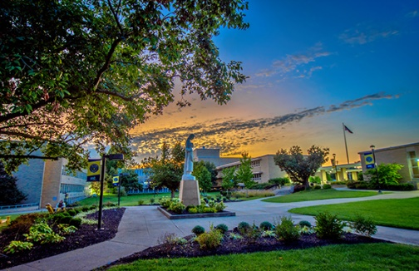
The Catholic Identity of the University is rooted in our Mission, in the Gospel values of service, compassion, and charity, and in the legacy and vision of our founders, the Sisters of Charity of Cincinnati. As an institution Catholic in faith and tradition, we commit ourselves to creating an inclusive environment where persons of all faiths and no faith are welcomed. We expect and value mutual respect, by all and for all, in our pursuit of knowledge and truth and in our search for the sacred.

The City of Cincinnati, Ohio

Cincinnati, Ohio is the 3rd most populated city in the state of Ohio. Home to a population of over 303,000 people of which approximately 51% is diverse. Ranked among the best places to live in the United States, as of May 2022, Cincinnati is ranked #1 in Ohio and #41 among 150 metro areas in the country. Downtown Cincinnati is a buzzing, urban destination where people come to work, live, and have fun. It’s home to large annual festivals, great food, cultural art venues, parades, and sporting events. Downtown Cincinnati touches the riverfront’s professional baseball and football stadiums and encompasses the community gathering spot, Fountain Square.

Venture a little deeper into the City, and you’ll find Over-The-Rhine (OTR), a historic neighborhood in transition, where you’ll see funky shops, locally owned restaurants, Washington Park, and Findlay Market, the state’s oldest continuously operated public market. The heart of Cincinnati may be downtown, but the city’s soul spreads across 52 distinct neighborhoods, reaching into the suburbs and beyond. Nearby neighborhoods, including Hyde Park, Mount Adams, Oakley, Spring Grove Village, Northside, and Pleasant Ridge have a unique welcoming character. It’s in these areas and others, that you’ll find the Cincinnati Zoo, Kings Island amusement park, upscale shopping and dining, local and world art, an annual professional tennis series, and more.

Nomination and Application Process

Salary

Salary will be competitive and commensurate with qualifications and experience.

How to Apply

Greenwood/Asher & Associates, LLC is assisting Mount St. Joseph University in this search. For best consideration, please apply before January 27, 2022. An application package includes a cover letter, CV, and a list of five references. Submission of application materials as PDF attachments is strongly encouraged. Initial screening of applications will begin immediately and continue until an appointment is made.

Please direct inquiries and nominations to:

Marion Frenche, Practice Leader, Diversity, Equity & Inclusion
Search Manager and Executive Search Consultant
marionfrenche@greenwoodsearch.com

Please submit application materials to:
https://www.paycomonline.net/v4/ats/web.php/jobs/ViewJobDetails?job=74883&clientkey=BC25C89BF322A723B1E209741EE99F00

Mount St. Joseph University values diversity and is committed to equal opportunity for all persons

