ACADEMIC ADVISING RESOURCE CENTER

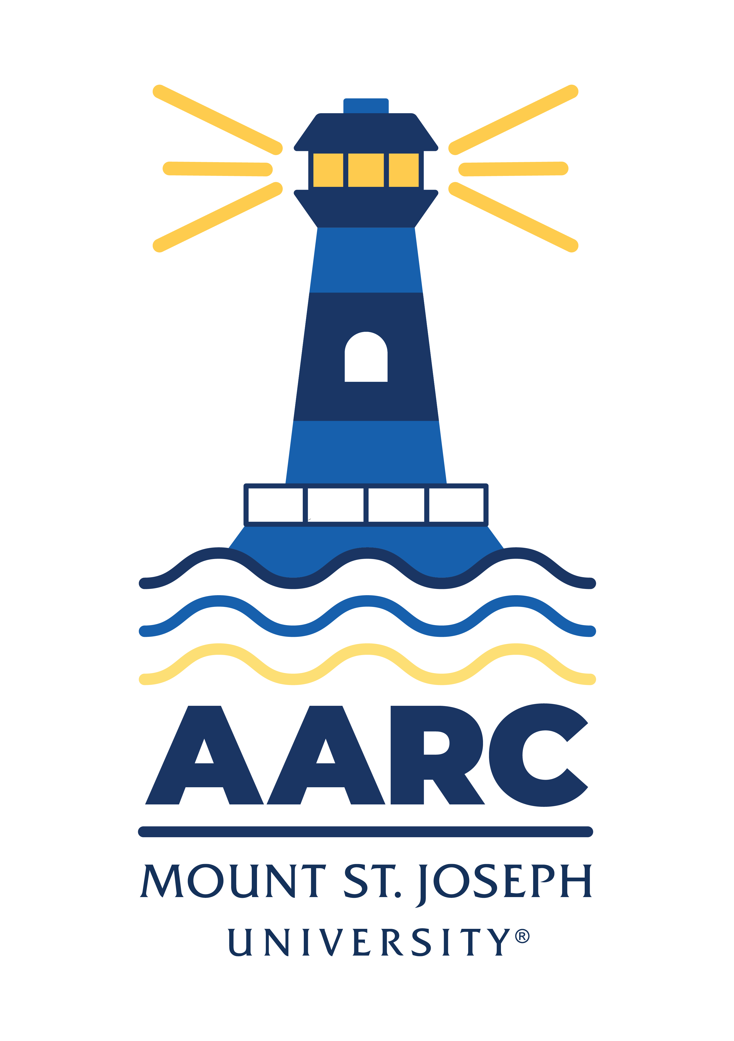
  - Newsletter— April 10, 2025

GOT A QUESTION? ask advising.

The Academic Advising Resource Center (AARC) is located in the Conlan Center, around the corner from the Registrar Office. Our team is here to help you any and all academic or advising questions. Drop-ins are welcome!

important TIPS & deadlines

If you missed registration, need advice on waitlists, or want to chat about what major/minor may be right for you, come talk to an advisor in the Advising Center (advising@msj.edu). We’re happy to help anytime!

Here are the remaining advising/registration dates:

*See the attached “Registration Guide” document for tips on searching for classes and registering on myMount.

Freshman April 10 at 6:00 AM, 6:30 AM, 7:00 AM, and 7:30 AM
New Students April 11 at 6:30 AM
Priority Registration for new students April 26 and May 10

life hacks with bpw

Q: I missed a few newsletters—are the old newsletters archived somewhere?

A: Holy cow, they are! I recommend reading my November 7 and November 21 “Life Hacks” from last semester for tips on managing your time and assignments/priorities in the end-of-semester crunch time.

Click the link below to find our archived newsletters—and tell a friend!

https://www.msj.edu/academics/academic-resources/academic-advising-resources/advising-newsletter/index.html

LIBRARY SUPPORT

With the semester coming to a close and research assignments looming, don’t panic! Reach out to schedule an appointment with a librarian. Whether in person or over Zoom, librarians can save you time by guiding you where to start your research, search strategies for locating information and evaluating information, and so much more!

KATE’S CORNER (academic survival tips)

Are you looking for a meaningful leadership opportunity? The FYE Peer Mentoring Program is seeking passionate and dedicated students to support first-year students as they transition to college life!

As a Peer Mentor, you will:
✅ Help first-year students navigate academic and social challenges
✅ Develop leadership, communication, and mentoring skills
✅ Build a supportive campus community
✅ Gain valuable experience for your resume

📅 Application Deadline: Friday 04 April
📝 Apply Here: https://forms.office.com/r/zCheymudqF

Contact Kate Mitchell (kathryn.mitchell@msj.edu) with questions!

HUDDLE Up with Joey

Don’t miss out on the final Huddle Up series event on April 14th from 4-5pm in the Mosaic Center in Harrington. The session will cover the importance of mental health, well-being, and creating self-care routines.

For more info, contact Joey Moore: joey.moore@msj.edu.

Wellness Tips
If you're experiencing stress, anxiety, or anger, our counselors and social workers are here to help.
📧 Email:Wellness.Center@msj.edu
📱 Call: 513-244-4949

For immediate access to teletherapy and wellness resources, sign up for Uwill using your MSJ email.

FOLLOW US ON INSTAGrAM!

Keep up with crucial dates and info about advising by following msj_advising on Instagram. Tell your friends!

